Mr. Henry,

This week in my project I got a lot further in the actual functionality of my site. I decided to go with a simple online shopping cart that way I could have tests for values adding up, log in names and passwords and a variety of other UI driven tests that could be tested.

Here is a screens of my site’s home page:

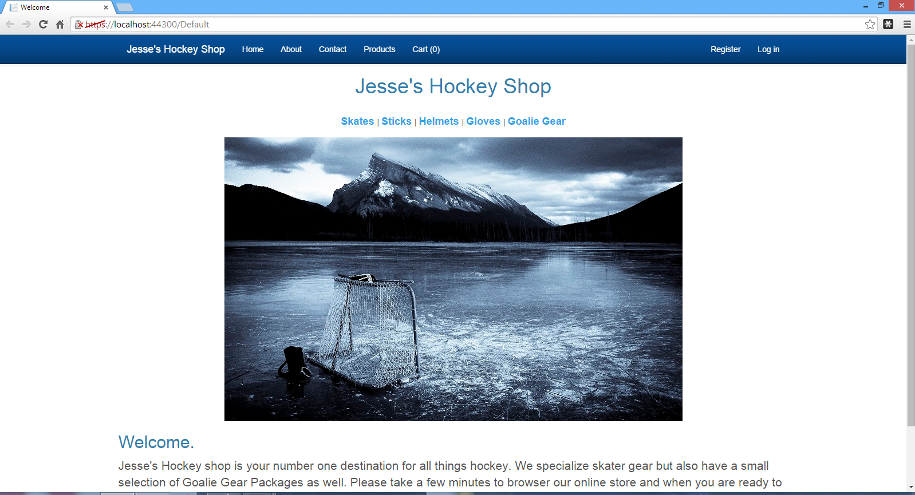

I’ve also have a products page as well as a shopping cart to store purchases:

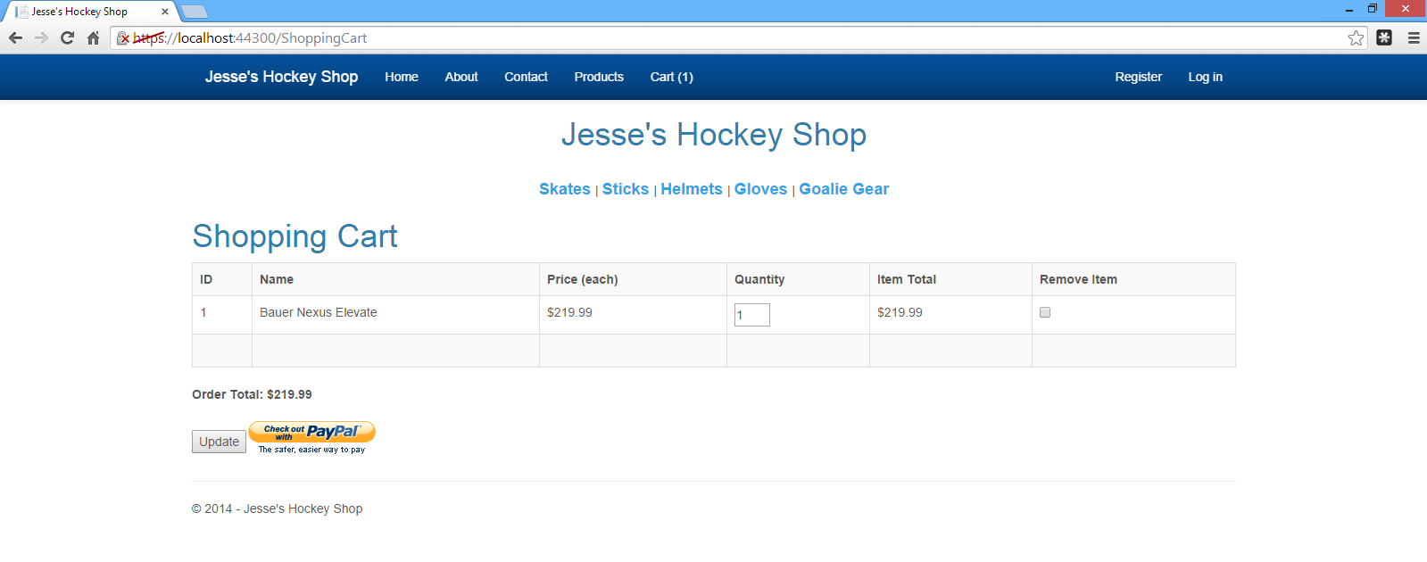

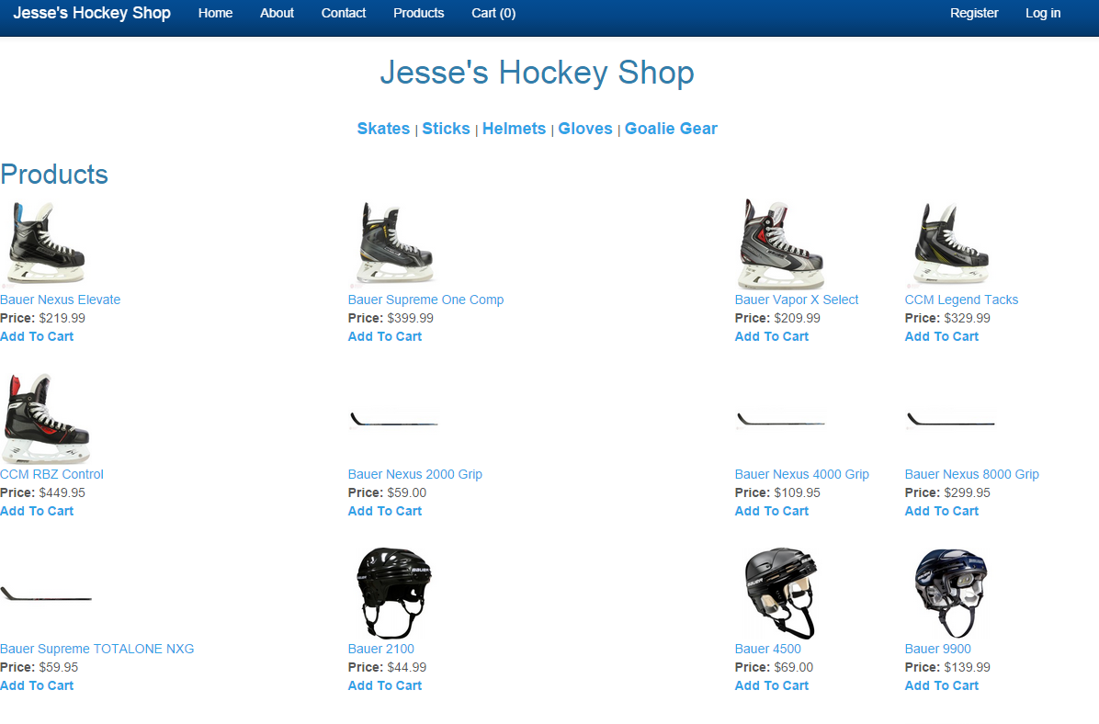

My CSS needs some help, but I wanted to get a good amount of functionality down before I put some finishing touches on it. Also I wanted to be sure to focus on testing abilities and not just building an ASP.NET page.

This next week I plan on setting up my Unit Tests to test some of my methods and set up some good cases.

I am definitely making some progress and getting the site together now I will focus on the actual testing and final the minor details like structure and CSS styles.

Hope this is the right track,

Jesse Fulcher